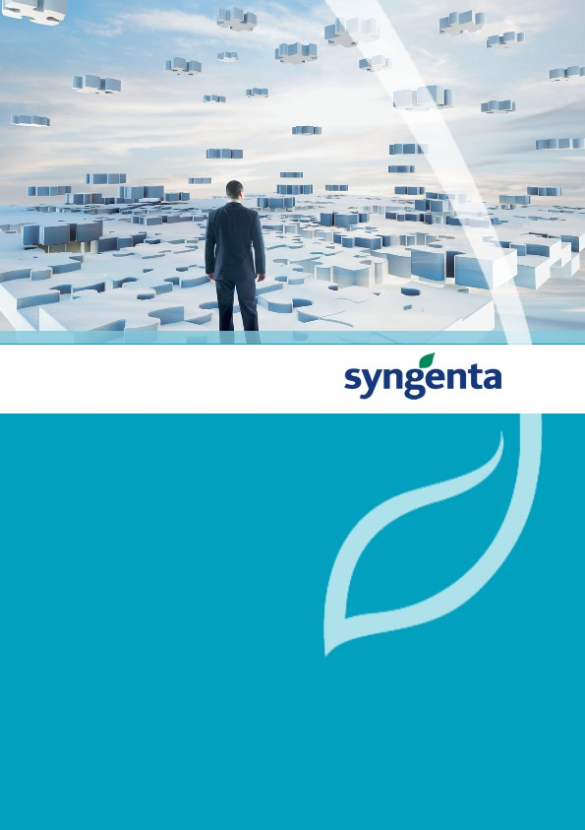

Satellite Connectivity Details

Satellite System Name : TMS

Ezequias Prado

9/28/2016

|  |  |
| --- | --- |
| Satellite Details | |
| Application name | **TMS** |
| Stream | **PnS** |
| Process Area |  |
| Description | **Transportation Management System** |
| ASM | **Ezequias Prado** |
| Supported by | **Kewill** |

|  |  |  |  |  |
| --- | --- | --- | --- | --- |
| Document History | | | | |
| Revision | Date | Short Description | Author(s) | Version used for gate: |
| ? | 9/28/2016 | ? | Luciano Daher | ? |
|  |  |  |  |  |
|  |  |  |  |  |

# Connection Details

|  |  |
| --- | --- |
| **Section** | **Details** |
| **Connection Type** | HTTP |
| **Application Type** | Web Application |
|  |  |
|  |  |

# Technical Details for Connectivity setup

|  |  |  |  |  |  |  |
| --- | --- | --- | --- | --- | --- | --- |
| **Environment** | **Host Name URL** | **IP address** | **Port no** | **Program ID (TCP/IP)** | **User** | **Password** |
| **DEV** | N/D | N/D | N/D | N/D | N/D | N/D |
| **IST** | https://cte.kewilltransport.net | 207.126.104.210 | 80 | ? | ? | ? |
| **UAT** | N/D | N/D | N/D | N/D | N/D | N/D |
| **PRD** | https://www.kewilltransport.net | 207.126.104.214 | 80 | ? | ? | ? |

# Procedure to Estabilish Connection

## Steps in SAP System

## Steps in Satellite System

You can select the following data exchange settings on the General tab of the Connectivity page:

* Transport
  + Specify how you want to process data exchange transactions using Kewill Transport. You have the following options:
* Web Services
  + Your organization uses web services to receive Kewill Transport data as XML files.
  + [11/10/2016 5:25:29 AM] chris williams: The CTE/Test URL:
    - https://ws-cte.kewilltransport.net/nistevows/importservice
  + The production URL:
    - https://ws.kewilltransport.net/nistevows/importservice
    - [11/10/2016 5:26:02 AM] chris williams: 207.126.104.213 ws-cte.kewilltransport.net
    - 207.126.104.217 ws.kewilltransport.net

## Steps in Middleware System

# Satellite Connectivity Architeture

## Logical View

Kewill’s application architecture is designed to provide optimal performance, scalability, integration, and configuration. Central to the Kewill application is the industry-standard Java 2 Enterprise Edition (J2EE) architecture from Sun Microsystems. J2EE defines architecture for enterprise Internet systems by combining standards for presentation (HTML, XML, Java Server Pages, servlets) with open standards for enterprise services with Enterprise Java Beans (EJBs). This architecture “abstracts away” key enterprise functionality such as messaging, load balancing, fault tolerance, security and scalability. Within the context of the J2EE, the Kewill architecture provides layers for role-based security, real-time agents, and multi-level caching, along with transparent transactional persistence to a RDBMS. This highly layered software design not only yields a scalable and configurable architecture, but it also provides a platform for optimal software reuse, thereby enabling rapid deployment and accelerated product evolution.

A critical component of high availability, throughput, performance and scalability of the Kewill architecture is its integration and use of the industry leading RDBMS technology from Oracle Corporation. The Kewill architecture also seamlessly integrates the industry leading LTL rating engine from SMC, optimization engine from ILOG, and B2B integration product from SeeBeyond Corporation. Through either loose or tight coupling of SeeBeyond, Kewill, clients’ EDI messages, XML or flat files are converted into Kewill standardized XML format for import into the IBM network. Likewise, Kewill standardized XML documents are exported to its clients through the SeeBeyond system. The SeeBeyond product was chosen for its large collection of data adaptors, its flexibility for both loose and tight coupling to IBM clients' systems, its configurability and its support of extremely high data throughput.



## Technical View

Use the General tab of the Connectivity page to define how your organization receives data exchange transactions from Kewill Transport.

